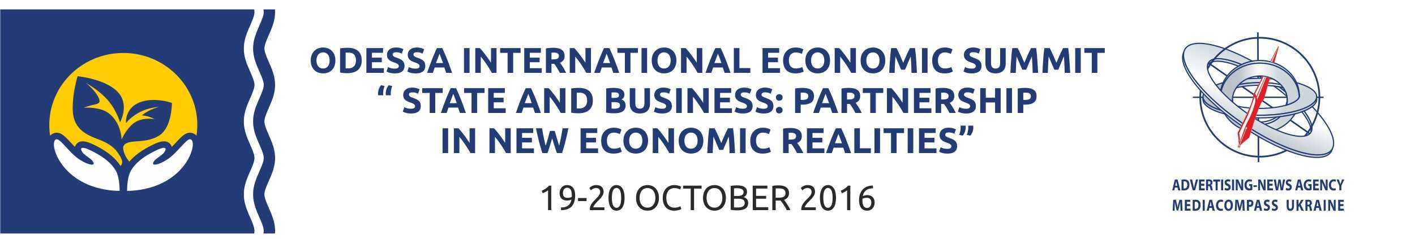
Press-release, October, 2015

TIME TO ACT: JOINT EFFORTS FOR STABILITY AND GROWTH

Nowadays Ukraine is at its turning historical moment. European integration is a factor that facilitates transition of economic relations between Ukraine and the EU to a new level.
The development of the modern economy necessitates state intervention in markets to ensure their competitiveness. In conditions of a worsening global economic crisis the private sector acquires a status of an equal partner of the state in solving strategic tasks of socio-economic development of the country. It is expected to expand cooperation between government, private sector and civil society, which is possible only in case of public-private partnership formation. Now it is very important for Ukraine to organize the process of interaction, to create a window that will help effective interaction with European and other markets.
With this aim Odessa international economic summit “Government and business: partnership in the new economic reality” (19-20 October, 2016, Odessa, Marine terminal) opens its doors within the framework of the International Black Sea Transport Forum 2016.
The aim of the Summit is to promote of public-private partnership development in Ukraine, to discuss problems and to find ways for solving; to bring designed strategies and economic development plans to international and political circles, to show our state as a country for placement of industrial facilities and improvement of Ukrainian image for foreign investors. Questions for discussion:
- Deregulation and improvement of business climate (extension of the moratorium on business inspections, VAT payment, regulation of land use);
- Export-import relations development between Ukraine and EU and other regions;
- Simplifying of business in Ukraine;
- Market control and supervision (market regulation);
- Agriculture industry and food production security.
The summit will gather leading economists, representatives of business and government to define the most effective instruments of economic development of Ukraine. B2B meeting with business representatives from Ukraine and other countries of the world, negotiations with representatives of the embassies of countries-strategic partners of Ukraine are planed within the framework of the Summit . The organizers plan the Summit as a permanent platform for formation of strategy of economic development of Ukraine, focused on the dialogue between experts, business and government, on exchanging the best international practices and, as a result, conversion of ideas into action.
We invite Your company to participate in the Summit and the formation of the program.
For participation please contact the organizing committee of the International Black Sea Transport Forum 2016.

The organizing Committee of the Forum
Tel./Fax: +38 (0482) 355999
e-mail: odessa@mediacompass.com.ua
stoyak@mediacompass.com.ua

